**IELTS LISTENING SIMULATION VOL.2**  
**CHOOSE THE RIGHT ANSWER**

## SECTION 1 (1-10)

#### **Questions 1-5**

Complete the following information using **NO MORE THAN THREE WORDS AND/OR NUMBERS** for each gap.

|  |  |
| --- | --- |
| Surname | 1 |
| Given name | Sharon |
| Address | 2, Tipton, TP3 4MB |
| Date of birth | 3 |
| Type of membership | annual |
| Amount due | 4 £ |
| Credit card number | 4673 9702 0361 |
| Expiry date | 5 |

#### **Questions 6-9**

Label the diagram of the gym, using **FOUR** of the following six labels.

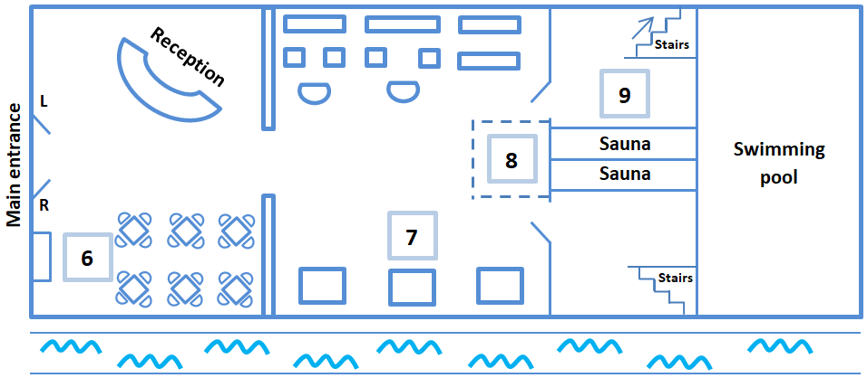Write the appropriate letter in the correct space on your answer sheet.

**LABELS**

|  |  |
| --- | --- |
| **A** free weights area  **B** ladies’ changing area  **C** men’s changing area | **D** refreshment area  **E** treadmills  **F** various machines |

6

7

8

9

#### **Question 10**

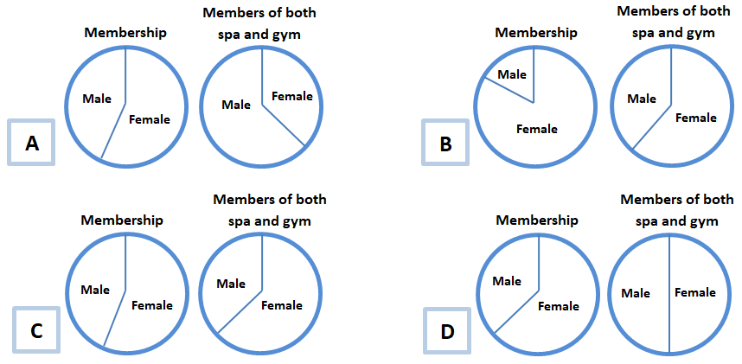Decide which pair of pie charts illustrate the membership of the gym and spa and write the appropriate letter on your answer sheet.

10

## SECTION 2 (11-20)

#### **Questions 11 and 12**

Complete the following sentences using **NO MORE THAN TWO WORDS** for each gap.

11 The university has produced a  to inform students about the different accommodation options available.

12 All catered and self-catered accommodation is close to the 

#### **Questions 13-16**

In boxes 13 -16 on your answer sheet, write

**A** if the statement applies to catered accommodation

**B**  if the statement applies to self-catered accommodation

**C** if the statement applies to private accommodation

**D** if the statement is not mentioned at all by the accommodation officer

13 Meals are included in the rent.

14This is the best accommodation for people who want to choose when they eat.

15 Most students live in this kind of accommodation.

16 This is the most expensive type of accommodation.

#### **Questions 17-20**

Decide which letter on the map (A - J) shows the location of each of the following university halls of residence.

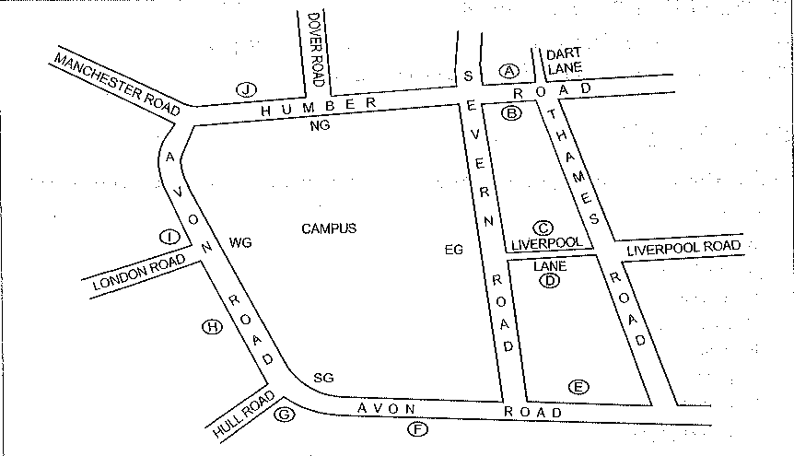

17Malvern Halls -

18Grampian Halls -

19 Brecon Halls -

20 Sperrin Halls -

## SECTION 3 (21-30)

#### **Questions 21-24**

Answer the questions using **NO MORE THAN THREE WORDS** for each answer.

21 When did Jenny arrive at the university? 

22 What is Tom going to study? 

23 What is Jenny going to study? 

24 What two items have the students been given? 

#### **Questions 25-27**

Complete the following sentences using **NO MORE THAN TWO WORDS AND/OR NUMBERS** for each gap.

25 Tom’s Halls of Residence is named .

26 Tom’s accommodation is afrom the campus.

27 Jenny’s accommodation is near the campus, close to the .

#### **Questions 28-30**

Decide which **THREE ITEMS** Jenny needs to buy and write the appropriate letters on your answer sheet in any order.

**A** binders

**B** notebooks

**C** notepaper

**D** paperclips

**E** pencils

**F**  pens

**G** primer

**H** printer paper

## SECTION 4 (31-40)

**Question 31**

**Which pie chart shows the ages of the Asian students surveyed?**

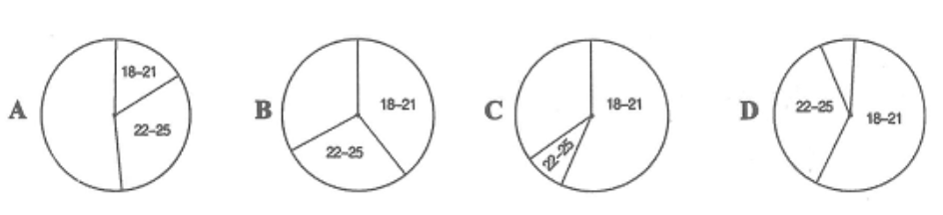

31

**Question 32**

**Which pie chart shows the main reasons Asian students wanted to study abroad?**

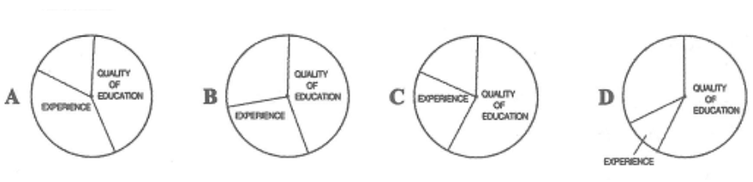

32

**Question 33**

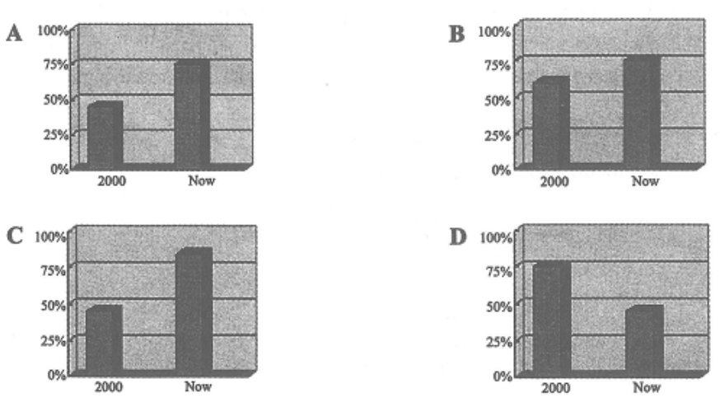**Which bar chart shows the percentage of Asian students who made Australia their first choice destination?**

33

#### **Questions 34 and 35**

Answer the following questions using **A NUMBER** for each answer.

34 Approximately how many foreign students enrolled in Australia in the year 2000?

35How much did Australia’s education exports rise by last year?

#### **Questions 36-40**

Complete the following sentences using **NO MORE THAN TWO WORDS OR NUMBERS** for each gap.

36 It became harder to get a for the USA after September 11.

37  of Asian students gave lower study fees as a reason for choosing Australia.

38 Asian students rank Australia number in terms of educational quality.

39  programmes are unlikely to reduce the number of students going abroad in the near future.

40 Asian students are increasingly using  to help arrange their studies abroad.